**Vinay Ramadasan**

**Hindustani Classical Vocalist**

Vinay Ramadasan hails from a musical family of North Kerala (Kuthuparamba, Kannur).

His initial lessons in music started at the age of 5 at Gandharva Mahavidyalay, a prestigious music school in Pune from Prof. Manohar Dabke.

Blessed with a soulful and very emotive voice, Vinay aspires to learn and excel at the intricacies of Indian Music.

With the basic initiation into music by his uncle ofPt. Ramesh Narayan (Disciple of Padmavibhushan Sangeet Marthand Pt. Jasraj ji), Vinay took guidance and tutelage from Shri. Hemang Mehta & Smt. Rajini Shrotri from Pune. He is now taking lessons of music from Pt. Raghunandan Panshikar in the vocal stream of Hindustani Shastriya Sangeet.

Vinay is an **A** **Grade** **artist** of All India Radio, Pune.

He has acquired his Master in Music degree from Bharti Vidyapeeth, Pune.

In his journey of music, a few honorary awards have come his way too. He has been bestowed with the prestigious title of ‘**Sangeet Pratibha’** by the King Of Kerala, His Highness Late Utradom Thirunaal Martanda Verma, at his Krishna Vilasom Palace, in the presence of the Cultural Minister of Kerala,

Mr. P J Joseph.

He has been awarded the highly reputed **'Swaroday Puraskar**' by the D.V. Paluskar Pratishthan, Pune by the Mathematician and a leading harmonium player Dr.Aravid Thatte, in the presence of the illustrious vocalist Pt. Vijay Koparkar.

He has been awarded best singer three times in a row by the CGEWCC (Central Government Employees Welfare Cultural Committee) for the years 2004, 05, 06.

Vinay has been a member of various colaborative presentations too.

He has been a integral part of various projects of Padmashree Taalyogi Pt. Suresh Talwalkar, the reputed Kathak Guru Vidushi Shama Bhate and Smt. Durga Jasraj.

He has performed at various prestigious stages like Pune Festival (Pune), Vylopilly Chain Of Concerts for Promoting Indian Classical Art, Music And Dance (A govt. of Kerala Initiative) (Trivandrum), Mewati Sangeet Prachaar Sangh (Trivandrum), Parampara (Pune), SA Va Ni 'Bhavtavya' series for upcoming young musicians, Pt. Motiram Maniram Sangeet Samaroh, Hyderabad, Mamasaheb Mujumdar Sangeet Samaroh, Indore, Pt. Jitendra Abhisheki Mahotsav, Bhopal, Bharat Bhavan, Bhopal, Sankatmochan Mandir Sangeet Samaroh and many other reputed music festival across India.

He has also performed on A.I.R. (Pune), Doordarshan (Mumbai, Lucknow, Patna and National), Jai Hind T.V (Kerala) and Manorama News Channel (Kerala), Insync, etc

He has sung for T.V. serials like “Kunjalimarakyaar” on Surya TV, “Mere Sai” on Sony TV.

He has composed music for many short films, television commercials and dance ballets.

He has given performances at various cities like Ahmedabad, Bangalore, Baroda, Cochin, Delhi, Indore, Jaipur, Kannur, Kolkata, Madhurai, Mumbai, Palghat, Thiruvananthapuram, Varanasi to name a few.

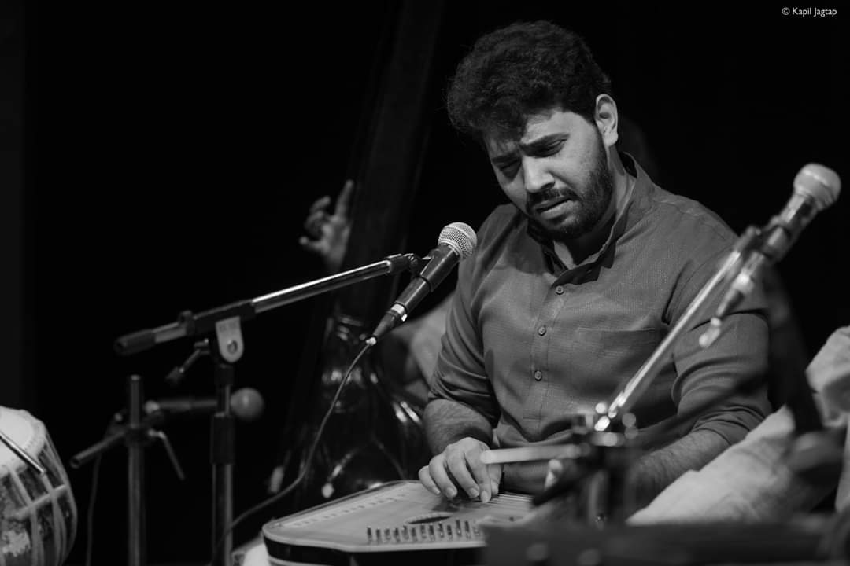

**Address**: B – 14/ 25, Vishrant Co-op Hsg. Soc., Vishrantwadi, Pune: 411015.

**Phone**: +918149103413, +919049481124. **Email**: vinayramadasan@yahoo.com